The Iliad- class activity packet
COMPLETE YOUR WORK ON YOUR OWN PAPER
- Character Notes
Before we begin reading, it will be helpful for you to have a basic idea of who the characters are and how they relate to each other. As we read, you will need to update the information and ask questions. At the end, you will draw a conclusion. For this section, complete the following:
  - Before reading: Identify each character- who is he or she?
  - While reading: Ask one question for each character. (Why did….?)
- After reading, Write a statement summarizing how the character impacted the story.

GREEK
- Achilles
- Agamemnon
- Ajax
- Calchas
- Patroclus
- Menelaus
- Helen
- Nestor
- Clytemnestra

ROMAN
- Priam
- Hector
- Paris
- Andromache
- Astyanax
- Cassandra
- Chryseis
- Briseis
- Hecuba
GODS
- Zeus
- Hera
- Athena
- Aphrodite
- Hermes
- Apollo
- Thetis
- Poseidon

- Map activity
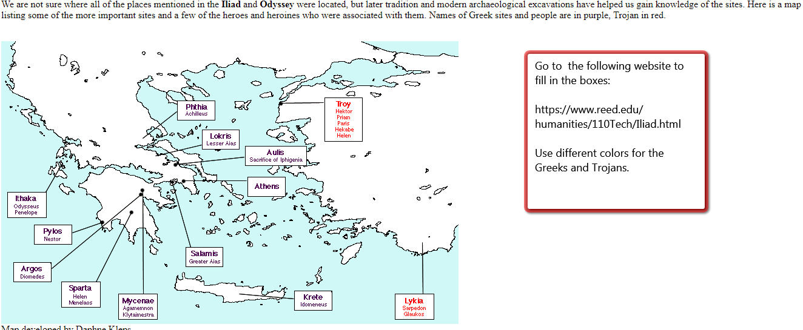
1.
2.
8.
9.
3.
11.
7.
6.
5.
10.
4.
- Guided Reading journals and Questions
  - Book 1: Quarrel, Oath, and Promise
    - Pre-reading journal
      - In your opinion, what is worth fighting for? Explain your feelings in at least 3-4 sentences.
      - Do you believe that there is anything worth dying for? Explain your opinion in at least 3-4 sentences.

    - Vocabulary- define each!

      - Oath
      - Besieged
      - Quarrel
      - Spoils
      - Assembly
      - Villain
      - revere
      - formidable
      - loath

    - Questions
      - How did Paris, Prince of Troy, start the Trojan War?
      - What did Agamemnon do that angered the god Apollo?
      - What do the soldiers think Agamemnon should do?
      - What does Calchas say must happen in order for the Greeks to be freed from the plague?
      - What does Agamemnon demand in exchange for his agreement to return Chrysies?
      - How did Agamemnon make Achilles angry?
      - How does Agamemnon threaten Achilles?
      - What does Athena do to intervene?
      - Why does Achilles treat Agamemnon’s men with respect?
      - According to Thetis, what does the future hold for Achilles?
Critical analysis Questions (ACE format)
      - Explain the FORESHADOWING in the first fifteen lines.
      - In the scene between Achilles and his mother, Thetis, there is a FLASHBACK to a prior event. Explain what happened and what purpose it serves in the story.
      - Briefly describe the roles of Apollo, Athena, and Thetis.

    - Post-reading activity
      - Find someone in the news who has reacted to a situation out of anger. What happened to make this person respond negatively? How is it apparent that they were reacting due to anger?

  - Book 22: The Desolation Before Troy
    - Pre-reading journal
      - Have you ever had to attend a funeral? Do you think they are important ceremonies? Explain your feelings in at least 3-4 sentences.

    - Vocabulary- define each!

      - Bereave
      - Trembled
      - Piteous
      - Entreat
      - Ramparts
      - Riven
      - Implacable
      - Arbiters
      - Bane
      - Diadem

    - Questions
      - Why does Apollo questions the wisdom of Achilles’ pursuit?
      - What reasons does Priam give Hector not to confront Achilles?
      - What does Hector’s mother predict will happen if he fights Achilles?
      - What options does Hector consider before making the decision on whether to fight Achilles?
      - How does Hector respond when Achilles gets close to him?
      - Why does Zeus favor Hector?
      - How does Athena trick Hector into fighting Achilles?
      - Why does Achilles refuse Hector’s request to treat his corpse with respect should he die?
      - How does Achilles injure Hector?
      - How do all of the men treat Hector’s body once he is dead?
      - What does Achilles do with Hector’s body and what does this show about him?
      - How does Andromache learn her husband is dead?
Critical analysis Questions (ACE format)
      - Explain the SIMILE in lines 193-198. What is being compared? What does it show us?
      - How does Zeus’s weighing of Achilles’ and Hector’s fates in line 246-252 FORESHADOW the end of the conflict?
      - Briefly describe the role that the gods play in the outcome of the battle between Achilles and Hector, then discuss whether you think it would have been different if they had not interfered.

    - Post-reading activity
      - Compare and contrast the characters of Achilles and Hector. How are they similar as warriors? What character flaws does each man possess? How important is family to them?

  - Book 24: A Grace Given in Sorrow
    - Pre-reading journal
      - Have you ever had an argument with someone and later you cannot remember what you were fighting about or why you were so angry? Explain your feelings in at least 3-4 sentences.

    - Vocabulary- define each!

      - Lament
      - Truce
      - Herald
      - Pretense
      - Urns
      - Visage
      - Allay
      - Dirge
      - Barrow
      - Stint

    - Questions
      - How does Hermes get Priam into Achilles’ camp?
      - What does Priam say to win Achilles’ attention?
      - What images in lines 79-93 suggest Priam’s age and weakness?
      - How does Achilles’ explain his good and bad fortune? Who does he blame?
      - How does Achilles’ threaten Priam?
      - Why does Achilles’ agree to return Hector’s body?
      - What conditions does Priam set for Hector’s burial?
      - How do the Trojans respond to the sight of Hector’s body?
      - What does Andromache predict her and her son’s futures will be like?
      - How does Helen describe the way that most Trojans have treated her? How did Hector treat her?
      - What was Hector’s funeral like?
Critical analysis Questions (ACE format)
      - Describe the aspects of Achilles’ CHARACTER that are revealed in his interaction with Priam. Has he changed?
      - Explain how Achilles’ offering of a food and a bed to Priam is significant.
      - At the end, three women, Andromache, Hecuba, and Helen, all give short speeches upon Hector’s return (lines 338-398). Choose one speech and describe the TONE of the speaker.

    - Post-reading activity
      - The Iliad is a story about war and the battles fought when one person or nation feels that another has done a bad deed to them. How is this situation relevant today? Discuss a modern example and find a news story to support your response.

