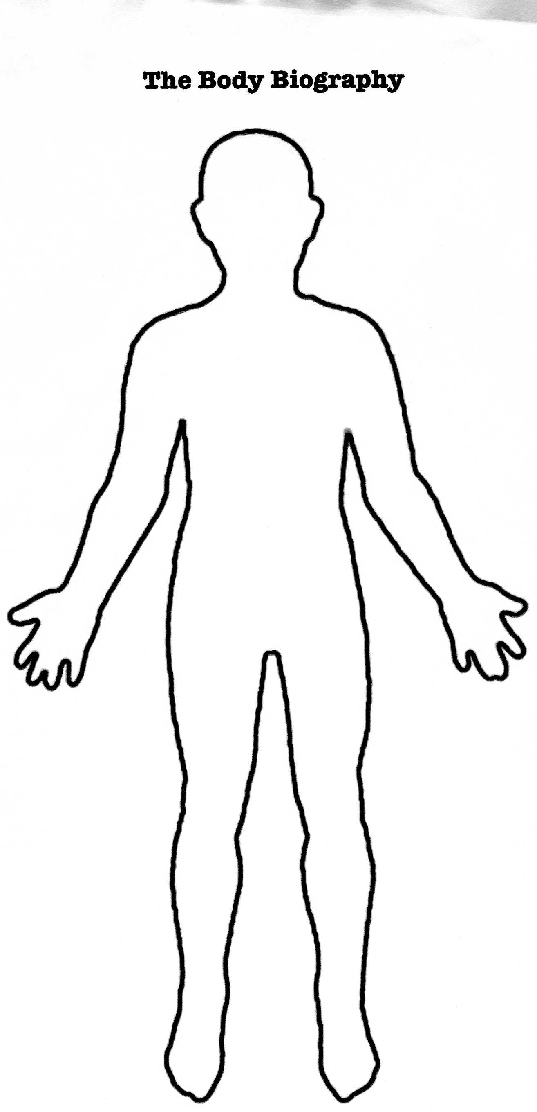
Body Biography Project

Book Title: The Kite Runner Character:

Your Name(s):

Criteria | Accomplished | Developing | Not completed
Quotes: At least three quotes and page #s given about the character (30)
Traits/Characteristics: At least two represented and illustrated. (10)
STEAL: one item for each element explained. (25)
Symbolic Items: At least three with descriptive references from the story
(15)
Visual Appeal: Creativity, design, etc. (10)
Extras: Any additional elements that bring the character to life. (10)

