Timeline of the Holocaust
Italicized entries refer to events described or alluded to in Night.
1933 The Nazi party takes power in Germany. Adolf Hitler becomes chancellor, or prime minister, of Germany. Nazis “temporarily” suspend civil liberties for all citizens. They are never restored.
The Nazis set up the ﬁrst concentration camp at Dachau. The ﬁrst inmates are two hundred Communists. Books contrary to Nazi beliefs are burned in public.
1934 Hitler combines the positions of chancellor and president to become “Fuhrer,” or leader, of Germany.
1935 Jews in Germany are deprived of citizenship and other fundamental rights. The Nazis intensify persecution of political dissidents and others considered “racially inferior” including “Gypsies,” Jehovah’s Witnesses, and homosexuals. Many are sent to concentration camps.
1936 The Olympic games are held in Germany; signs barring Jews from public places are removed until the event is over. 1938 German troops annex Austria. On Kristallnacht (the “Night of Broken Glass”), Nazi gangs physically attack Jews throughout Germany and Austria.
1939 In March, Germany takes over a neighboring nation, Czechoslovakia. On September 1, Germany invades Poland. World War II begins in Europe.
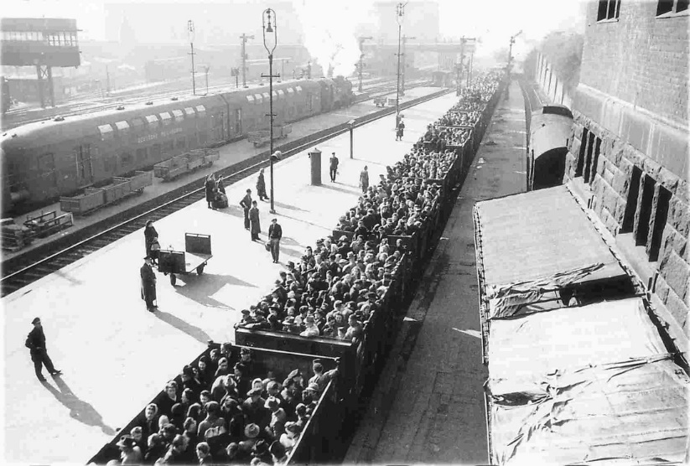
Hitler orders the systematic murder of the mentally and physically disabled in Germany and Austria. Polish Jews are ordered to register and relocate. They are also required to wear armbands or yellow stars.
1940 Nazis begin deporting German Jews to Poland. Jews are forced into ghettos. Germany conquers one nation after another in Western Europe including the Netherlands, Denmark, Norway, Belgium, Luxembourg, and France. With Germany’s backing, Hungary annexes parts of Romania, including Sighet and other towns in northern Transylvania.
1941 Germany attacks the Soviet Union. Jews throughout Europe are forced into ghettos and internment camps. Mobile killing units begin the systematic slaughter of Jews. In two days, one of those units was responsible for the murder of 33,771 Ukrainian Jews at Babi Yar—the largest single massacre of the Holocaust. Hungary deports 17,000 foreign and “stateless” Jews. Several thousand are used as slave laborers. The Nazis massacre the rest. The ﬁrst death camp at Chelmno in Poland begins operations. Germany, as an ally of Japan, declares war on the United States immediately after the bombing of Pearl Harbor.
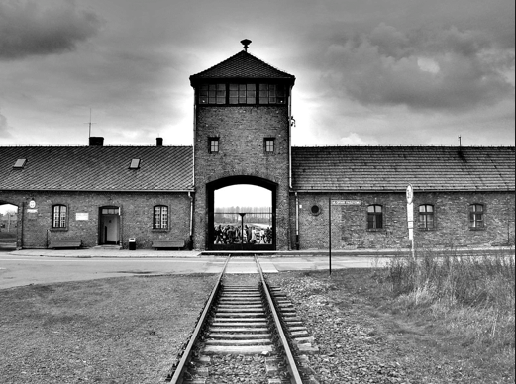
1942 At the Wannsee Conference, Nazi ofﬁcials turn over the “Final Solution”— their plan to kill all European Jews—to the bureaucracy. Five more death camps begin operation in Poland: Majdanek, Sobibor, Treblinka, Belzec, and Auschwitz-Birkenau.
March: About 20 to 25 percent of the Jews who would die in the Holocaust have already perished. The ghettos of Eastern Europe are emptied as thousands of Jews are shipped to death camps. The United States, Britain, and the Soviet Union acknowledge that Germans were systematically murdering the Jews of Europe.
1943 February: About 80 to 85 percent of the Jews who would die in the Holocaust have already perished.
April: Jews in Poland’s Warsaw Ghetto strike back as the Nazis begin new rounds of deportations. It takes nearly a month for the Nazis to put down the uprising.
1944 March: Hitler occupies Hungary; by June, the Germans are deporting twelve thousand Hungarian Jews a day to Auschwitz.
1945 January: As the Russian army pushes west, the Nazis begin to evacuate death camps, including Auschwitz.
April: American forces liberate the prisoners in Buchenwald.
May: World War II ends in Europe with Hitler’s defeat. The Holocaust is over; about one-third of all the Jews in the world are murdered and the survivors are homeless.
1946 An International Military Tribunal created by Britain, France, the United States, and the Soviet Union tries Nazi leaders for war crimes and crimes against humanity in Nuremberg.

